PROBABILITY
Pearson Edexcel - Tuesday 21 May 2019 - Paper 1 (Non-Calculator) Foundation Tier

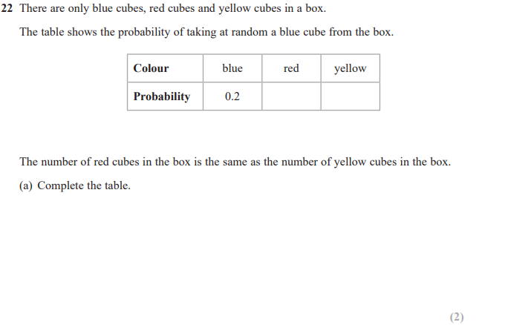
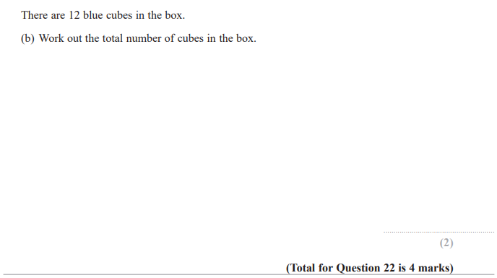

Pearson Edexcel - Thursday 6 June 2019 - Paper 2 (Calculator) Foundation Tier

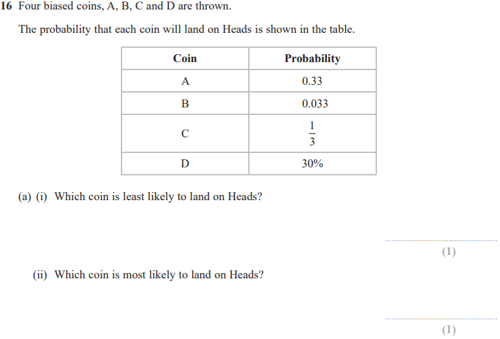

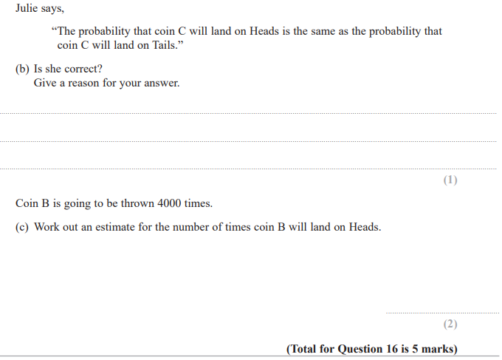

Pearson Edexcel - Tuesday 12 June 2018 - Paper 3 (Calculator) Foundation Tier

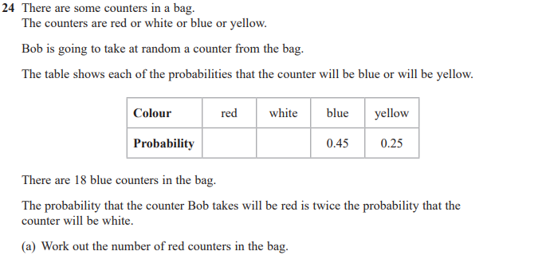
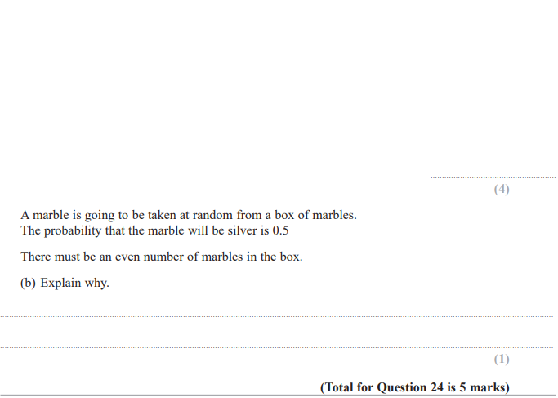

Pearson Edexcel - Monday 6 November 2017 - Paper 2 (Calculator) Foundation Tier

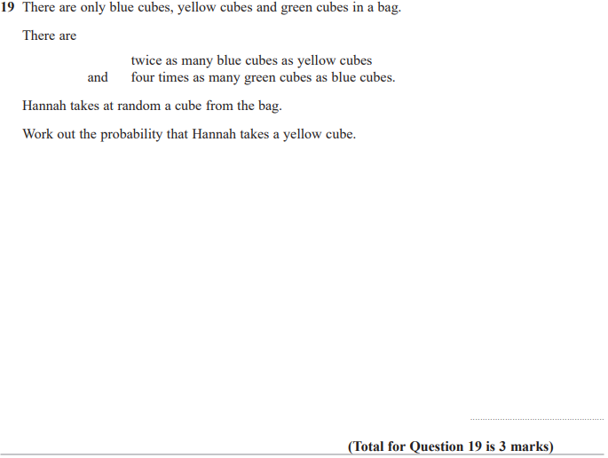

Pearson Edexcel - Wednesday 8 November 2017 - Paper 3 (Calculator) Foundation Tier

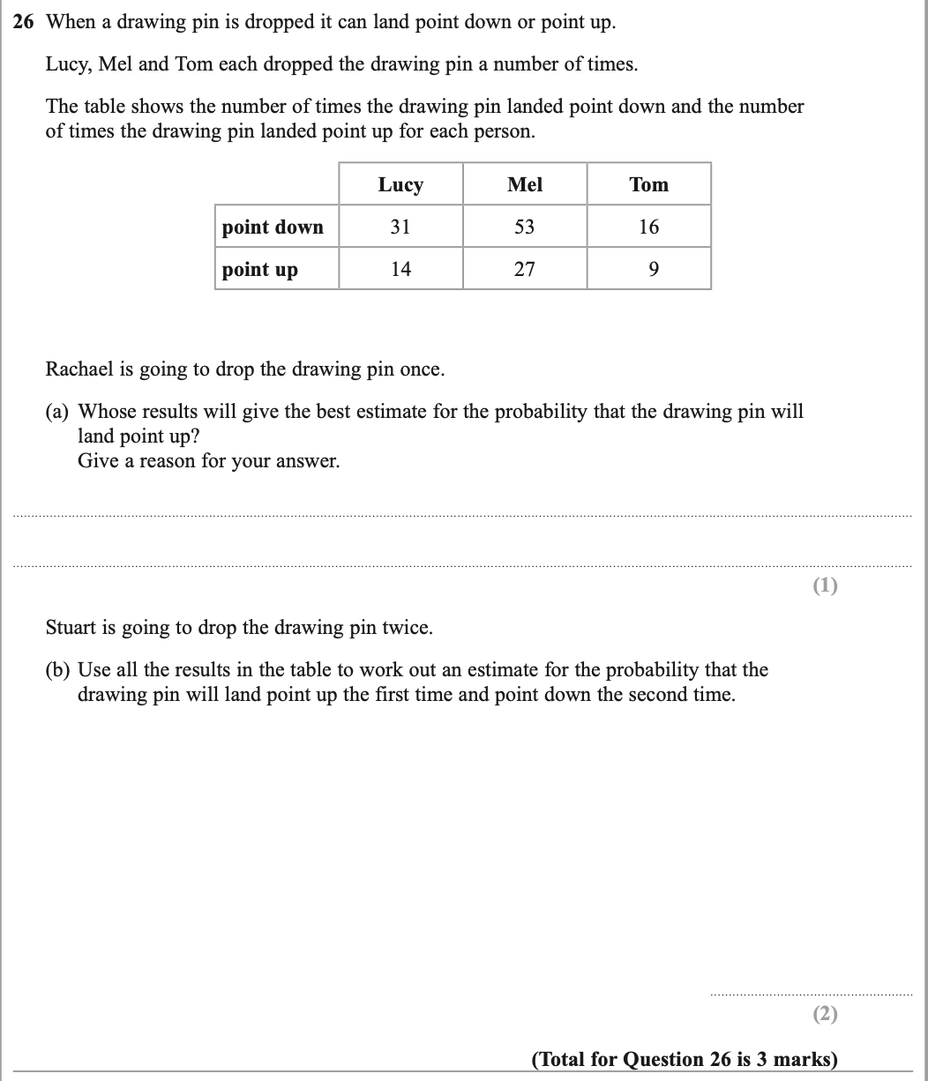

Pearson Edexcel – Specimen 2 - Paper 1 (Non-Calculator) Foundation Tier

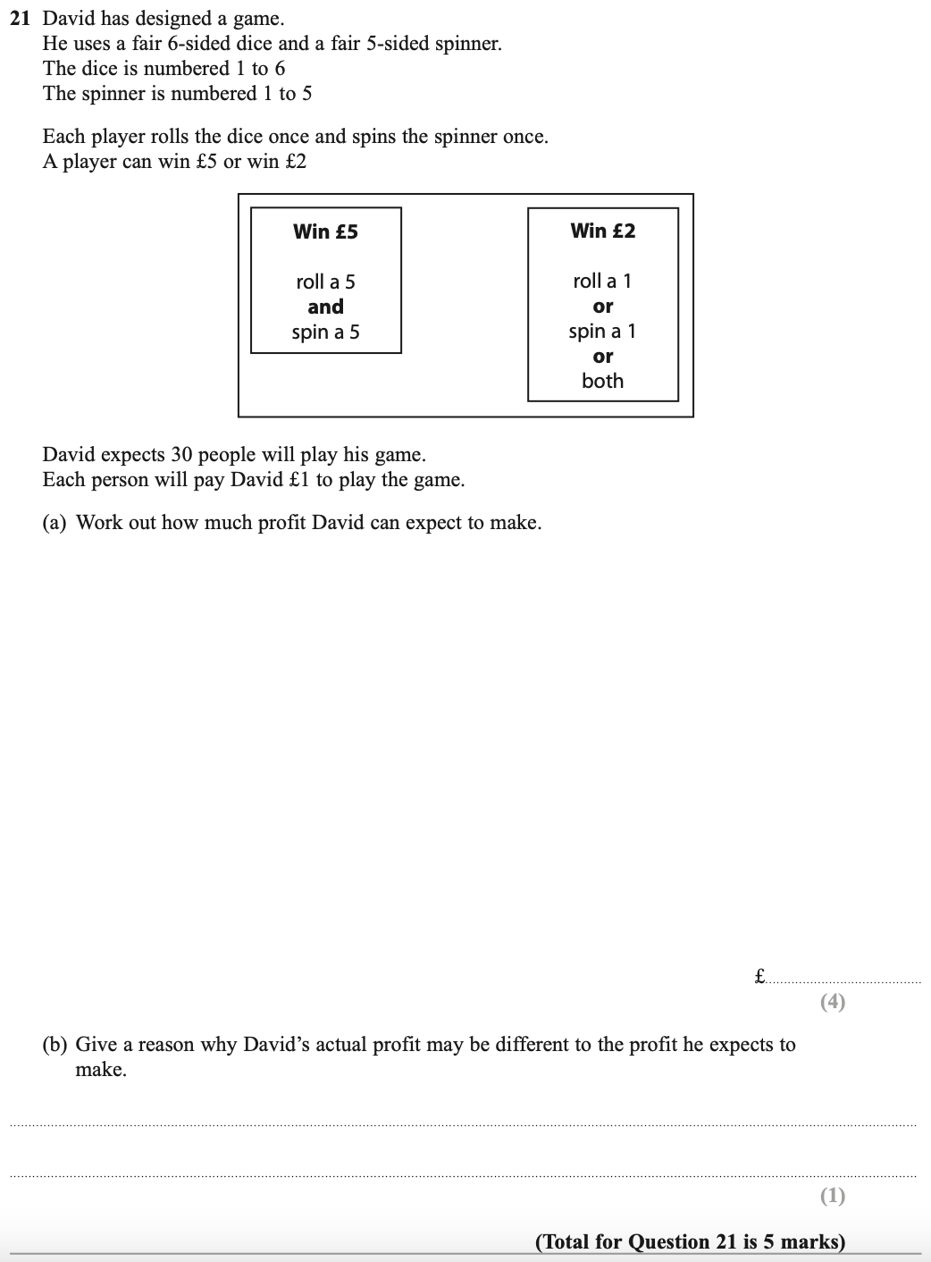

Pearson Edexcel – Specimen 2 - Paper 3 (Calculator) Foundation Tier

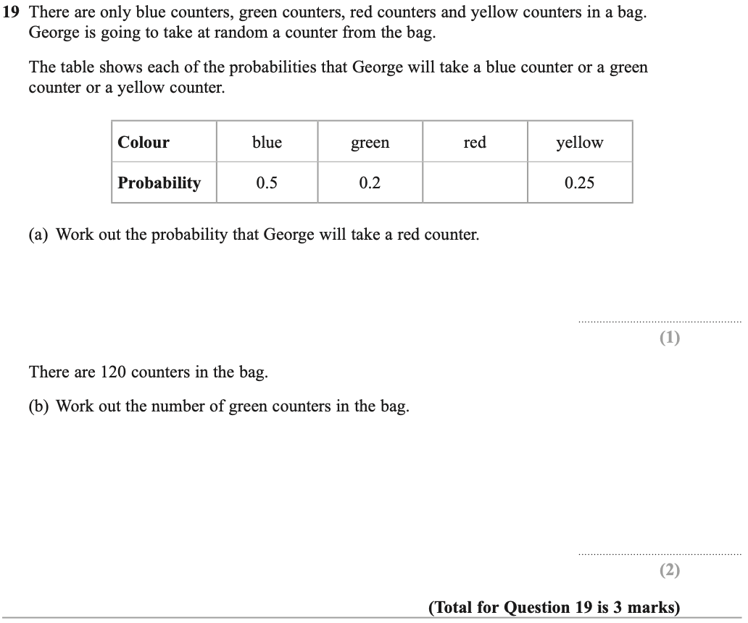

Pearson Edexcel – Specimen 1 - Paper 1 (Non-Calculator) Foundation Tier

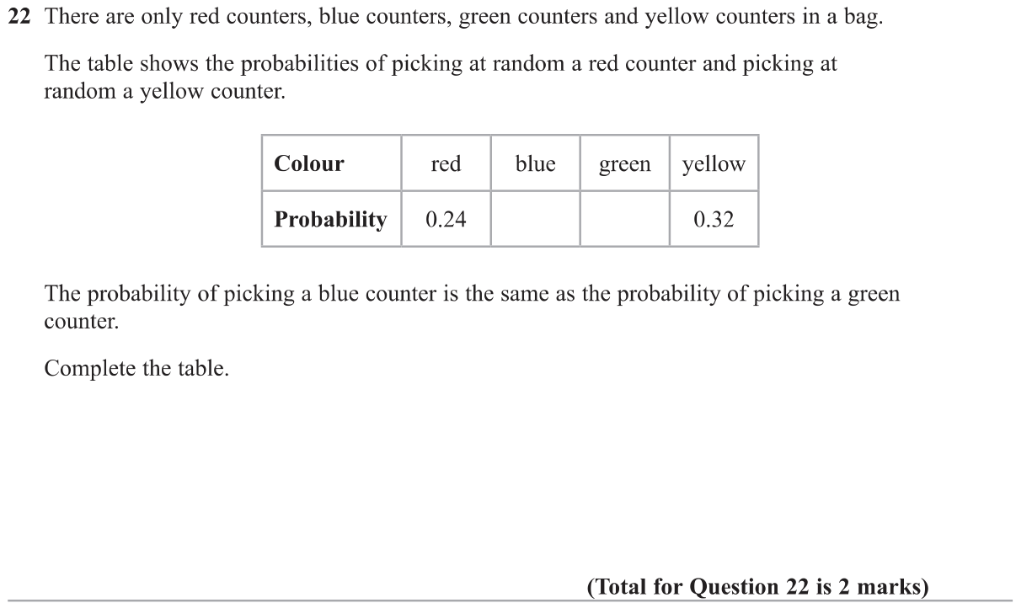

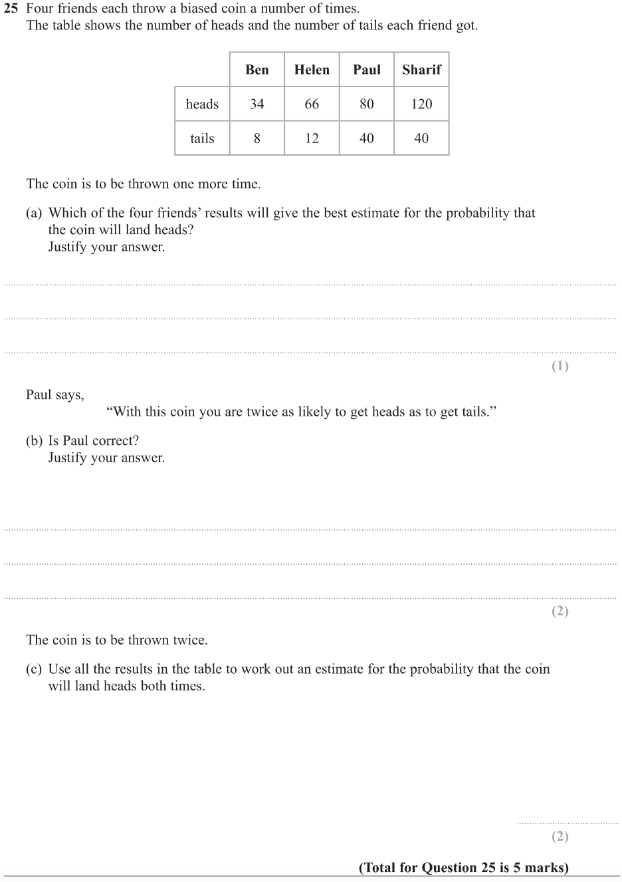
OCR – Tuesday 03 November 2020- Morning - Paper 1 (Calculator) Foundation Tier

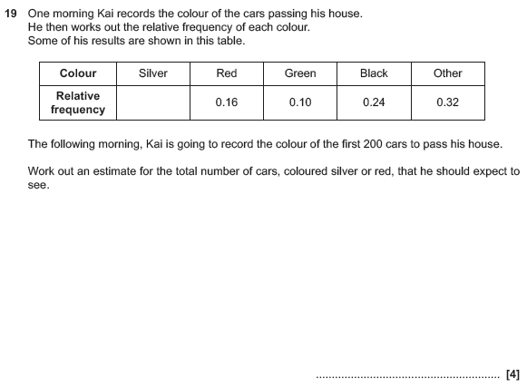

OCR November 09 November 2020- Morning (Calculator) Foundation Tier
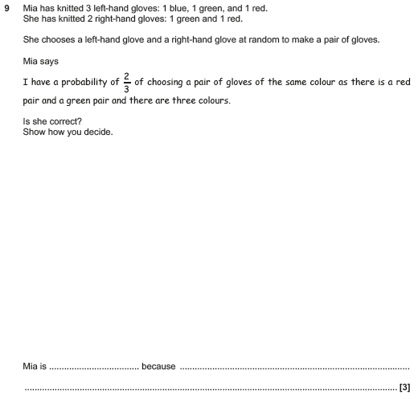

OCR Monday 11 November 2019 – Afternoon (Calculator) Foundation Tier

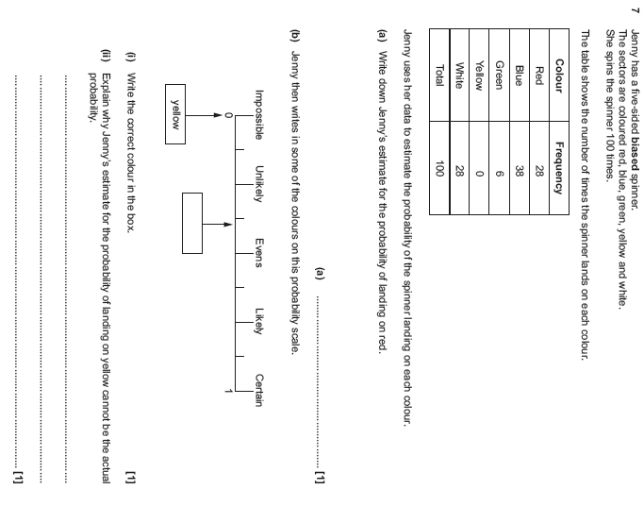

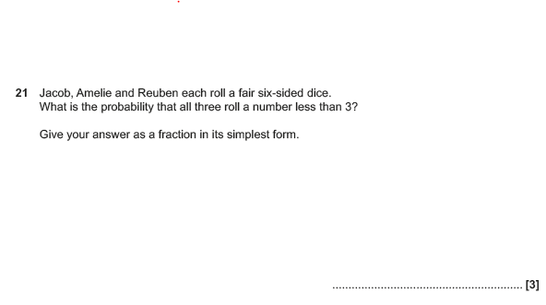

OCR Thursday 6 June 2019 – Morning (Non-Calculator) Foundation Tier

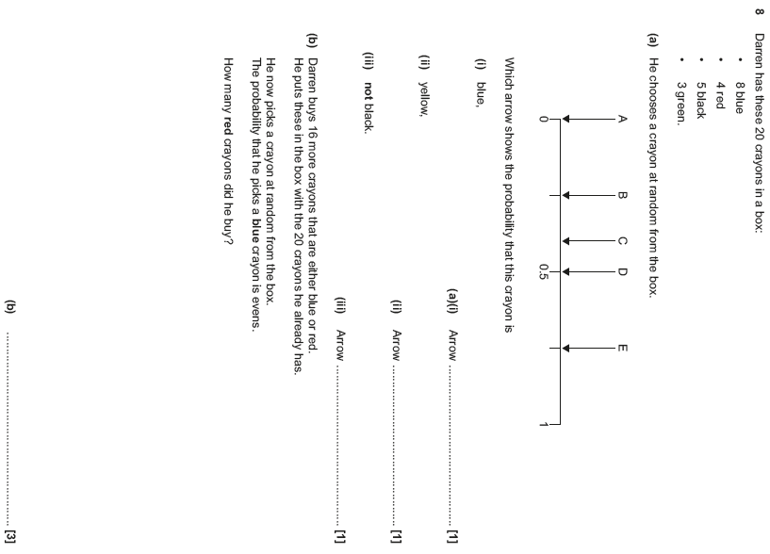

OCR Tuesday 11 June 2019 – Morning (Calculator) Foundation Tier

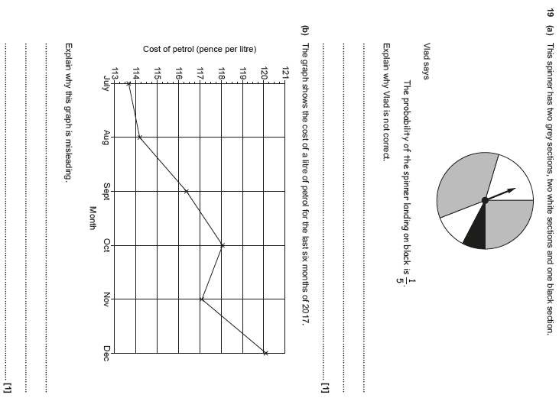

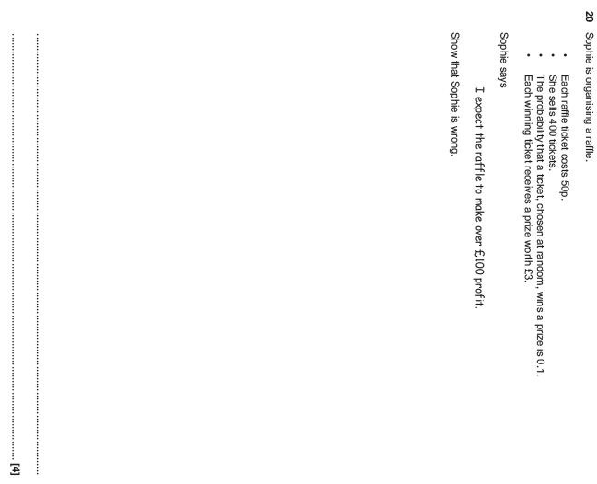

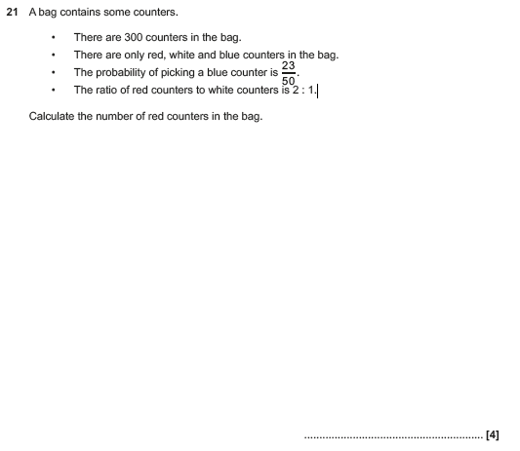

OCR Monday 24 May 2018 – Morning (Calculator) Foundation Tier
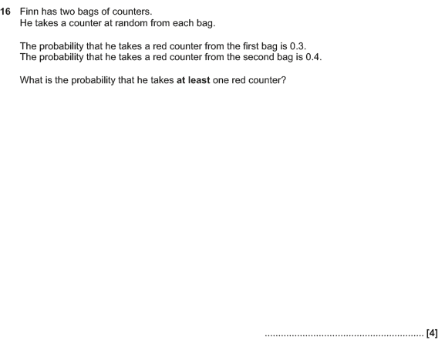

OCR Thursday 7 June 2018 – Morning (Non-Calculator) Foundation Tier
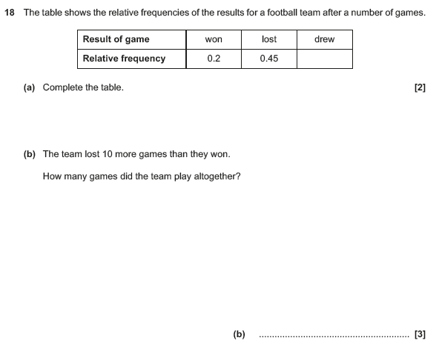

OCR Thursday 8 June 2017 – Morning (Non - Calculator) Foundation Tier

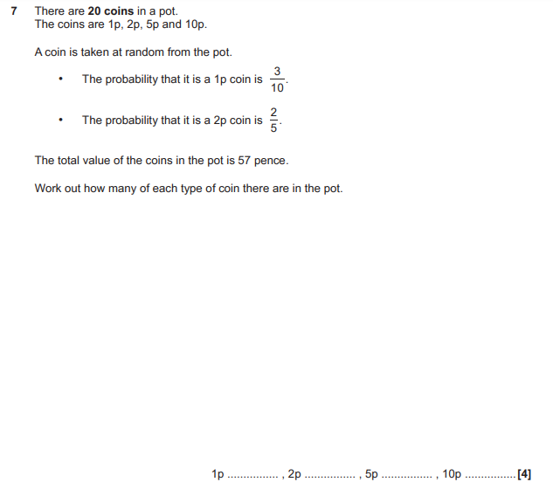

OCR Tuesday 13 June 2017 – Morning (Calculator) Foundation Tier

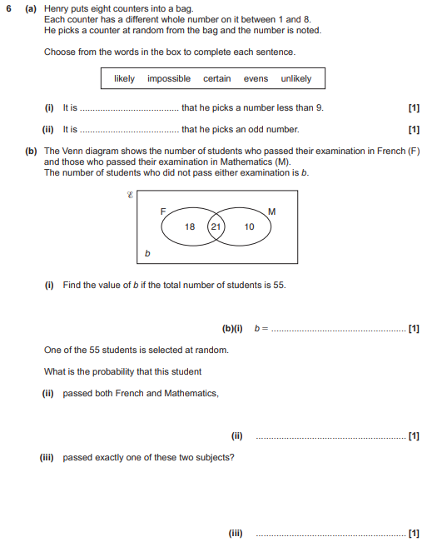

OCR Tuesday 13 June 2017 – Morning (Calculator) Foundation Tier

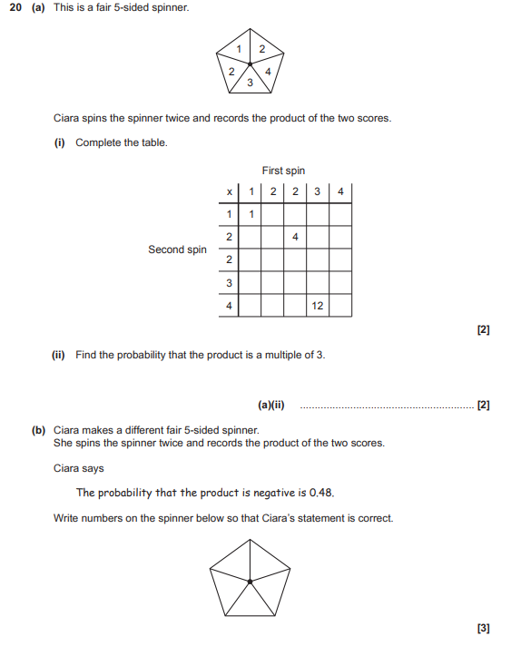

OCR Sample Question Paper 1 – Morning/Afternoon (Calculator) Foundation Tier

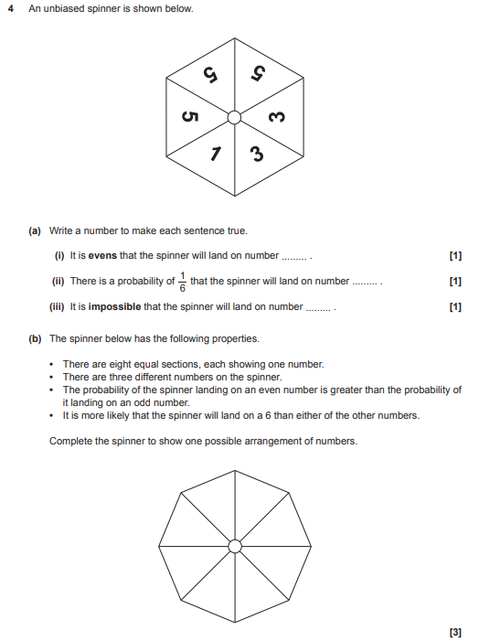

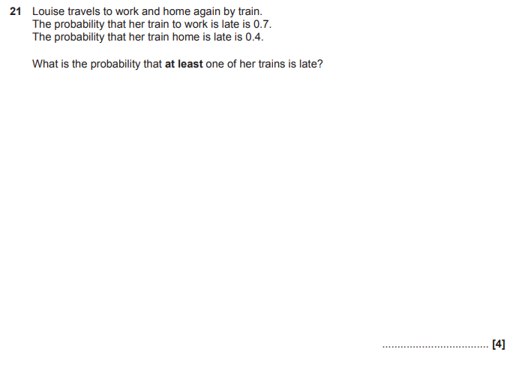

OCR Sample Question Paper 2 – Morning/Afternoon (Non - Calculator) Foundation Tier

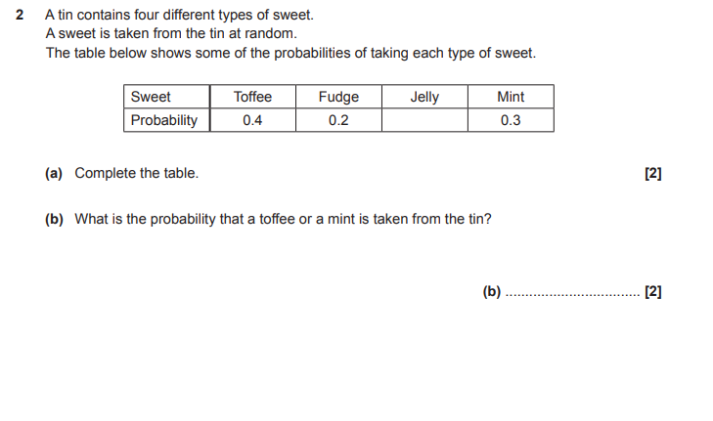

AQA Monday 12 November 2018 – Morning (Calculator) Foundation Tier

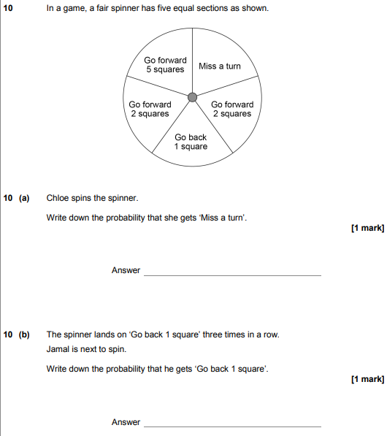
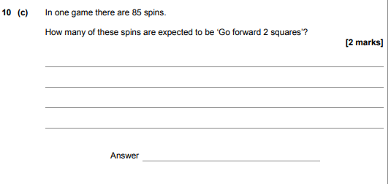

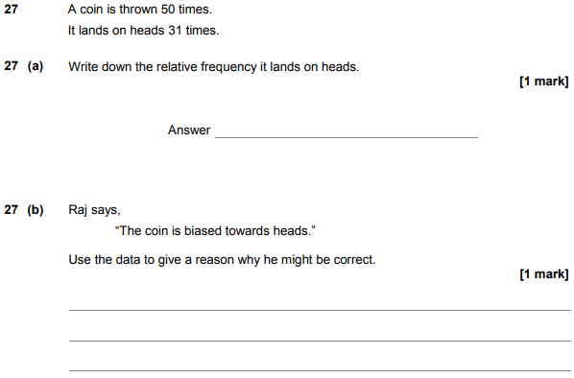

AQA Thursday 8 June 2017– Morning (Calculator) Foundation Tier

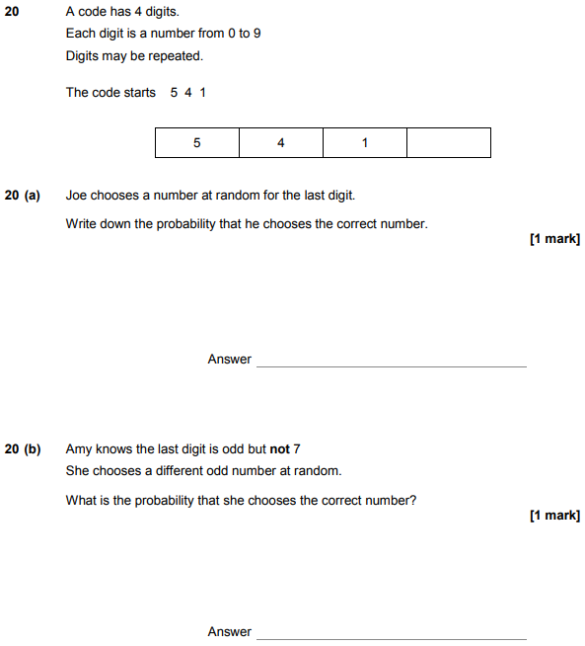

AQA Tuesday 13 June 2017 Morning– Morning (Calculator) Foundation Tier

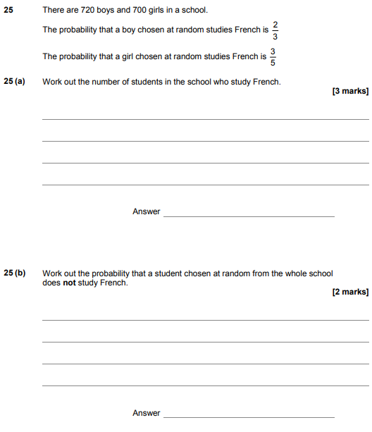

AQA Sample Paper 2– Morning (Calculator) Foundation Tier

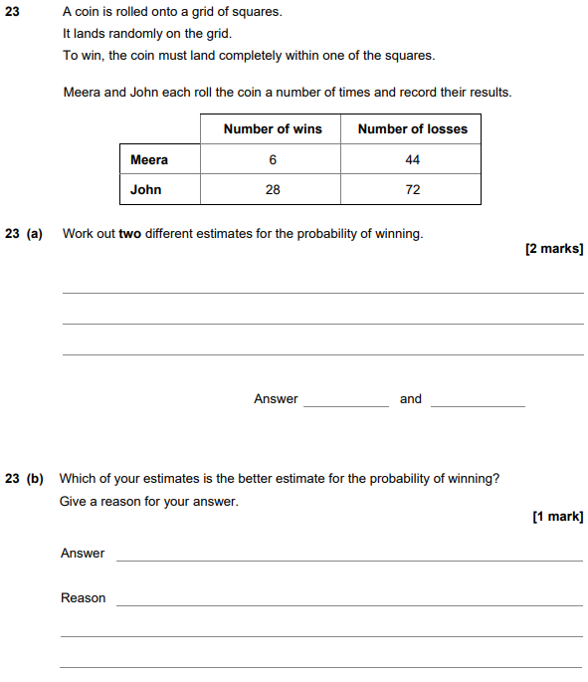

AQA Sample Paper 3– Morning (Calculator) Foundation Tier

